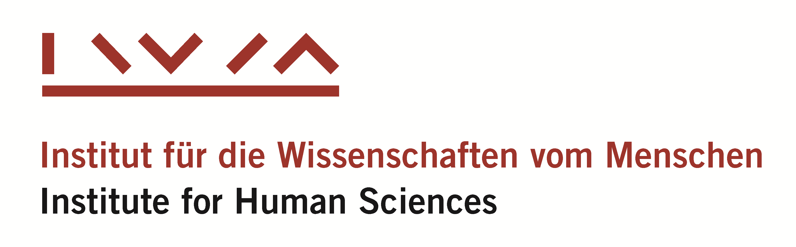

CEU Postdoctoral Fellowships

at the Institute for Human Sciences, Vienna

2023-2024

APPLICATION FORM
Please return your complete application materials to
kovacsn@ceu.edu
Academic Cooperation and Research Support Office (ACRO), CEU
Deadline: 17 April, 2023

APPLICANT
Family name |  | First name
 |  |  | Male □ Female □
Nationality | Date of birth |  | Gender

TITLE OF PROPOSED RESEARCH PROJECT

EDUCATION
Ph.D. in
Department / Institute at CEU
Name of Supervisor
Date of your doctoral degree
Expected date of graduation

Academic degree(s) | University, city, country | Date

PROFESSIONAL AFFILIATION
Name of institution
Position
From date

APPLICATION INFO
Expected start date of scholarship (dd/mm/yyyy) End date (dd/mm/yyyy)
Date of submission:

CONTACT DETAILS
Street, No. | City, post code
E-mail | Phone

Checklist
□ Application Form
□ Project Proposal
□ Abstract
□ CV + Publication List
□ 2 Recommendation letters
□ Second recommendation letter
□ CEU Transcript [printout from Infosys]
□ Photo (high resolution)

